USIU Africa

DSA 3050A – ADVANCED POWER BI EXAMINATION

Global Superstore Sales Analytics Dashboard

A Complete Business Intelligence Solution

Tanveer Omar

~752
PartA: Data Acquizition and Understanding

Domain: E-commerce / Retail Sales Analytics
Business Problem: Analyze global sales performance, identify profitable markets,
understand return patterns, and optimize regional operations

Dataset Source: Kaggle Global Superstore Dataset
URL: [ https://www.kaggle.com/datasets/rohitgrewal/global-superstore-data?resource=download]
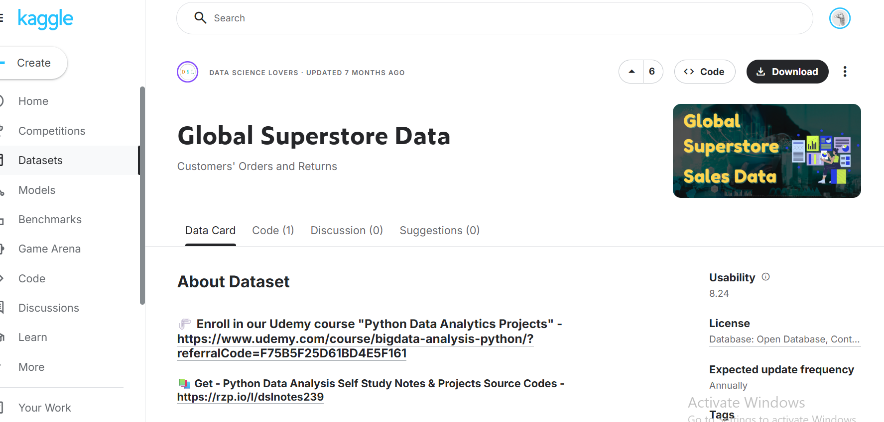

Key Tables:
- Orders (51,290 rows): Fact table containing all transactions
- Returns (2,033 rows): Returned order records
- People (24 rows): Sales representatives by region

Variables include:
- Categorical: Category, Segment, Market, Region
- Numerical: Sales, Profit, Quantity, Discount
- Date: Order Date, Ship Date

Rich dataset with time intelligence potential, multiple dimensions,
return analysis capability, and sufficient row count for advanced analysis.

Confirmation of 3 Tables and data loaded:
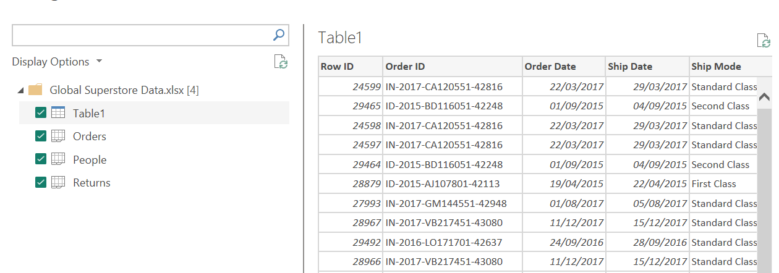

Part B: Data Cleaning and Transformation in Power Query

Cleaning:

Transformation 1: removing unnecesary Columns

- I didnt think row id was very useful as we already have Order ID as a primary key
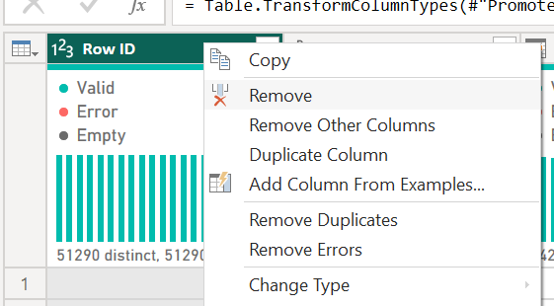

After removal
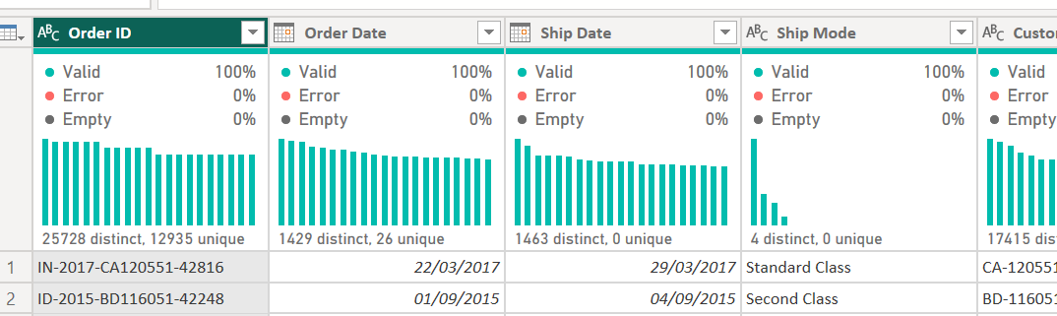

Transformation 2: Changing Data Type

a) Order date from text to date
Before:
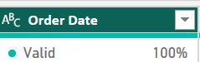

Transformation
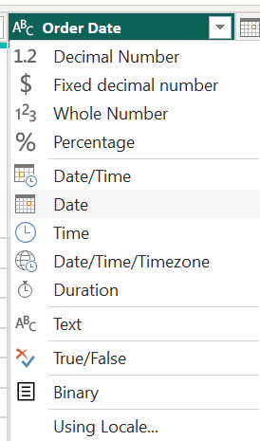

After
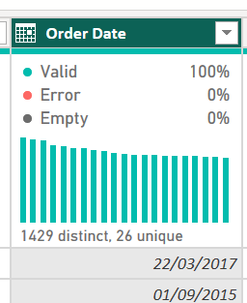

b) Sales from Text to Decimals

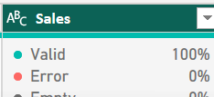

Transformation

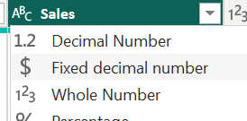

Final
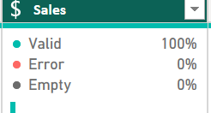

c) Profit From Decimal to Fixed Decimal
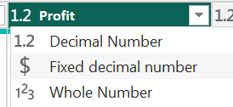

Final
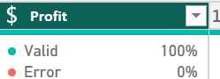

Transformation 3: Removing Duplicate Rows
Removing Duplicates from Order ID
Before
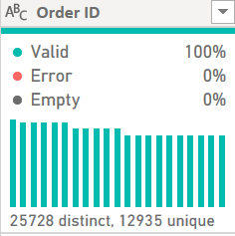

We can see there are quite a few duplicates, and since this is a Primary key duplicates are problematic
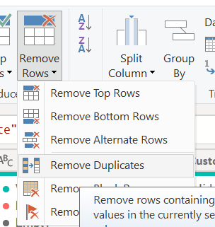

AFTER
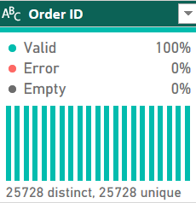

Transfromation 4: Replacing Missing Postal codes with Unknown
I chose to replace with unknown instead of deleting all unknowns because there is such a huge portion missing that it would shrink the data considerably

Before
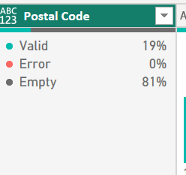

Transformation
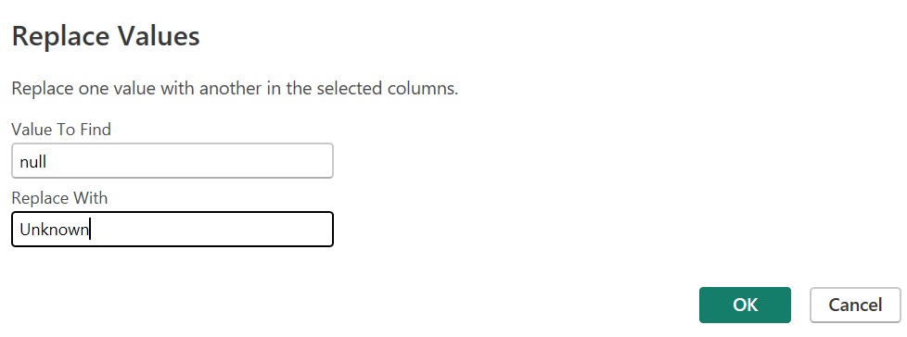

After
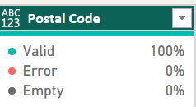

Transformation 5: Fix column Names
the column names in the people and returns table are incorrect
a) Persons Table
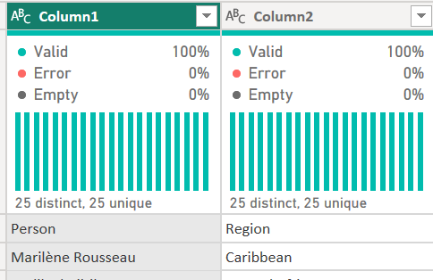

Transformation
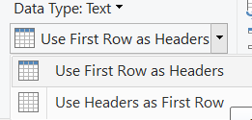

Final
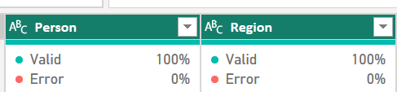

b) Retruns Table
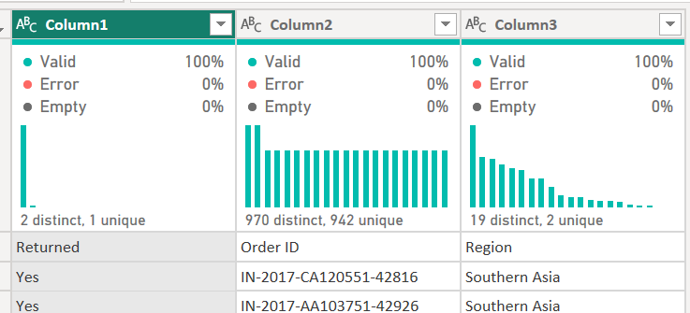

Final
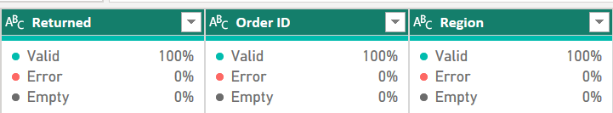

Transformation 6: Trim Customer Names
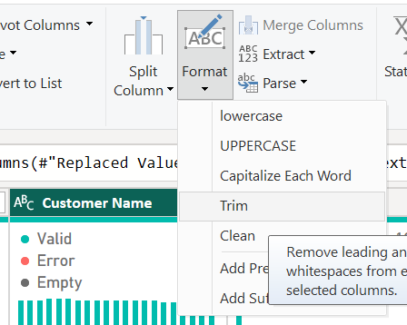

Transformation 7: Cleaning Customer Names
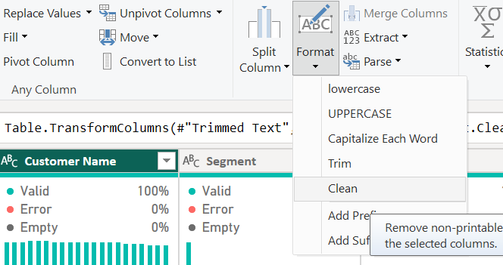

Transformation 8: Extracting Year and Month from Order Date
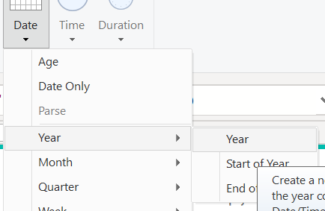

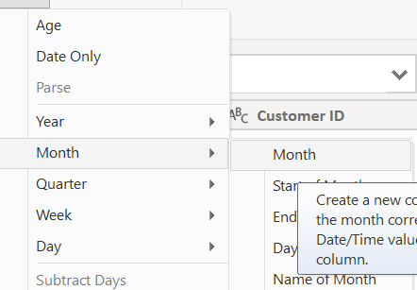

Final
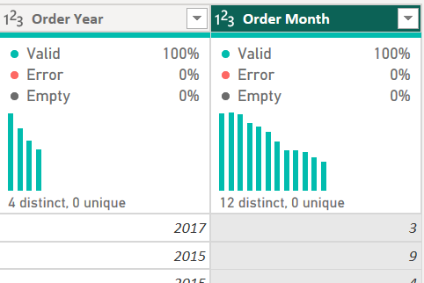

Transformation 9: Creating an order month Name
I did this because it might be useful to see the month name in visualization
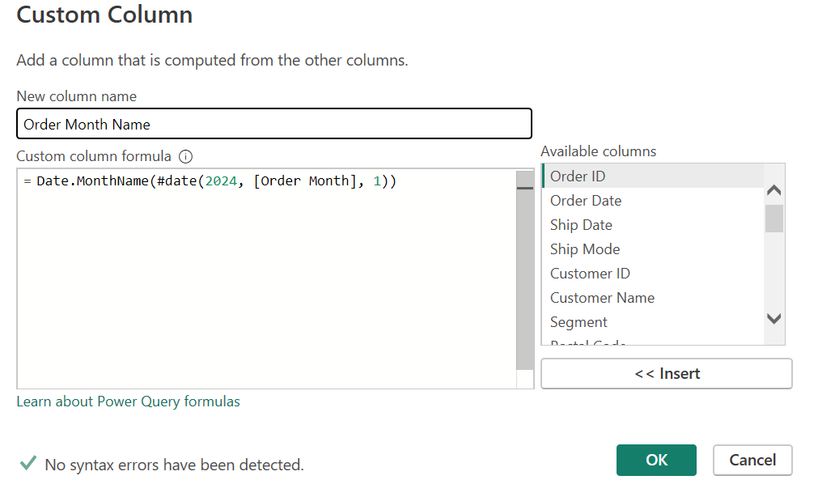

Final
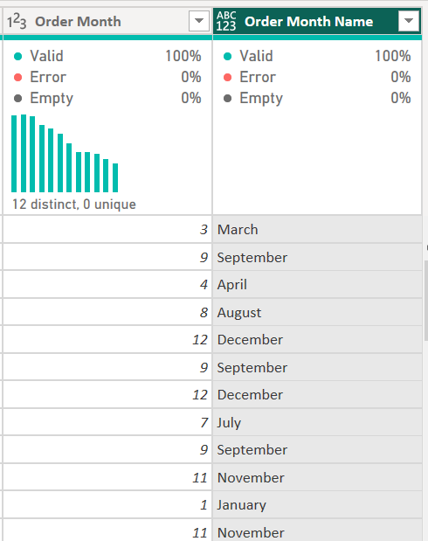

Transformation 10: Splitting Product Name into Brand Name and Product Description
Its clear that there is a comma delimiter
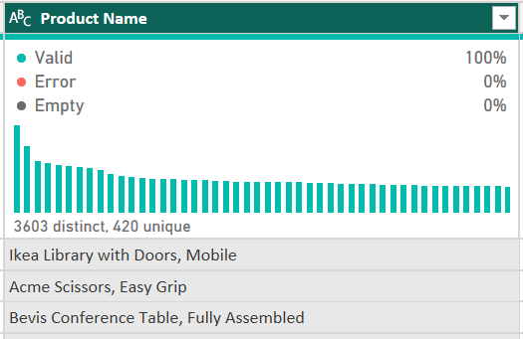

Transformation
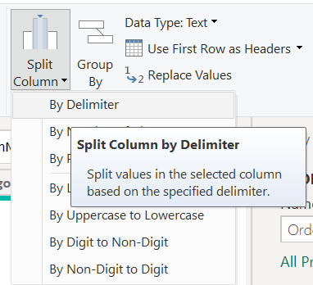

Final
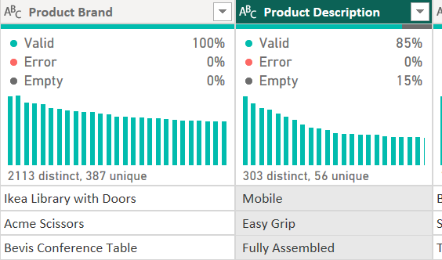

Transformation 11: in Returns table, removing duplicate Order Ids
Original
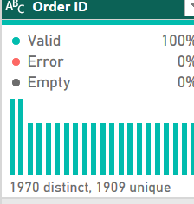

Transformation
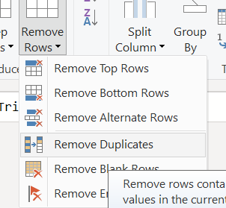

Final
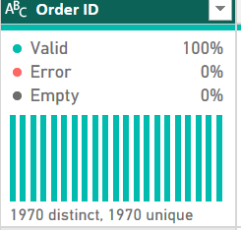

Dimension tables:

Transformation 12: Creating DimProdcut Table
I made a Dim Product Table,by duplicating and removing all columns except Product ID, Category, Sub-category, Product Name,
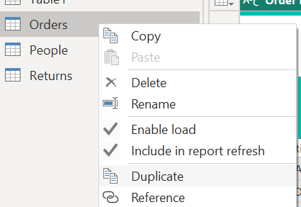

Final
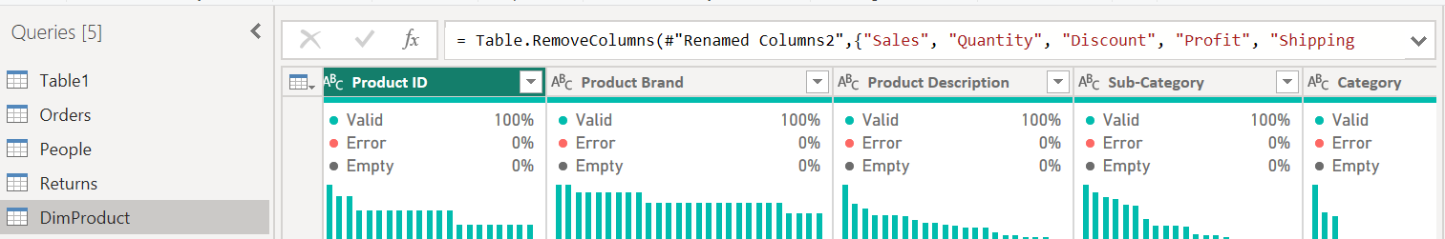

Transformation 13: Creating DimCustomer Table
I did the same for Customers by keeping only customer related Variables
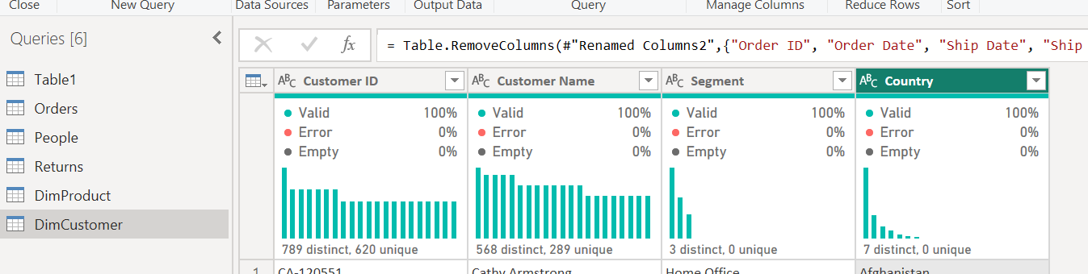

Transformation 14: Create DimGeography table
I did the same for DimGeography by extracting only geography related Data

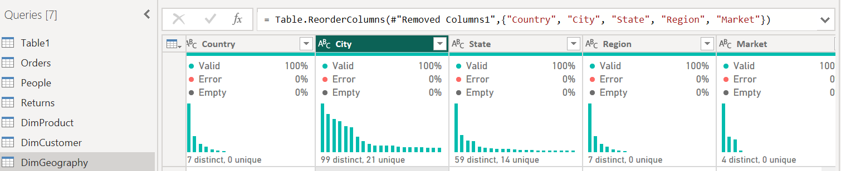

Transformation 15: Renaming Orders to Sales, people to DimPeople and returns to DimReturns
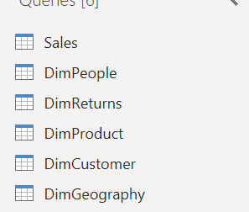

ALL TRANSFORMAATIONS;
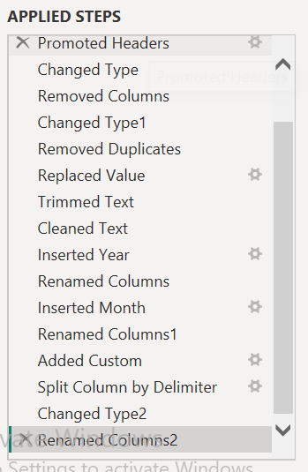

Part C: Data Modelling
Creating Data table in Dax
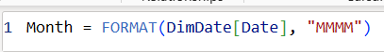





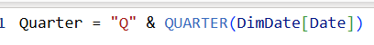



Final Date Table
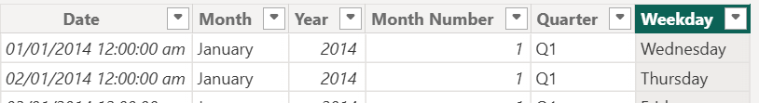
Marking as Date Table
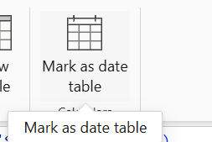

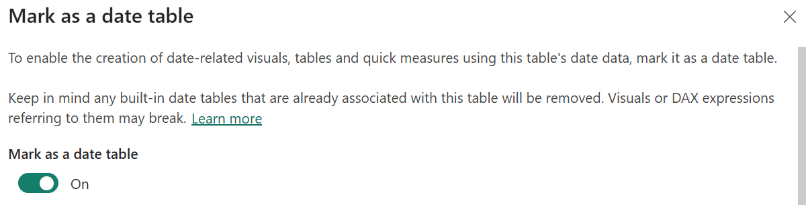

CREATING RELATIONSHIPS:
Dim Date to sales
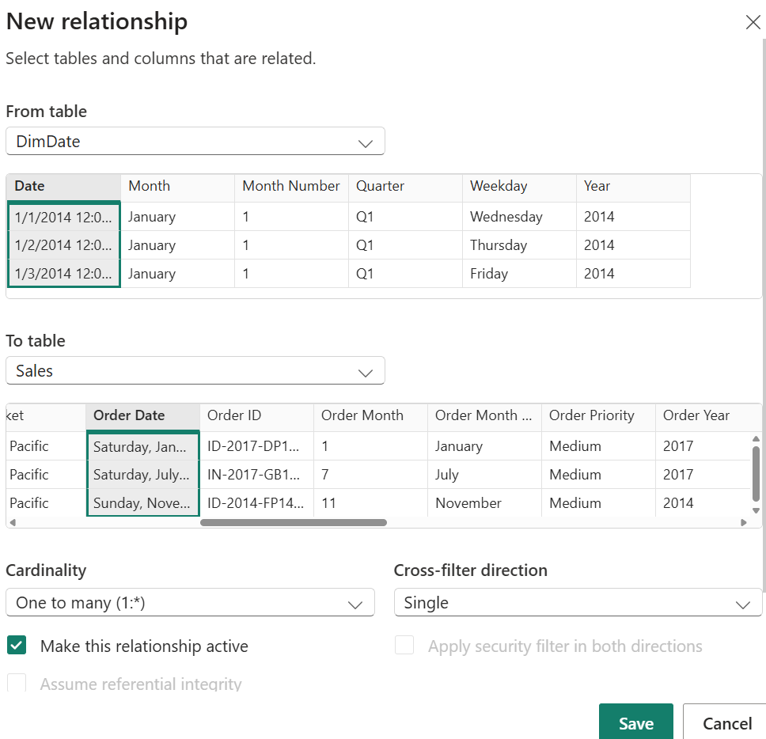

DimProduct to Sales
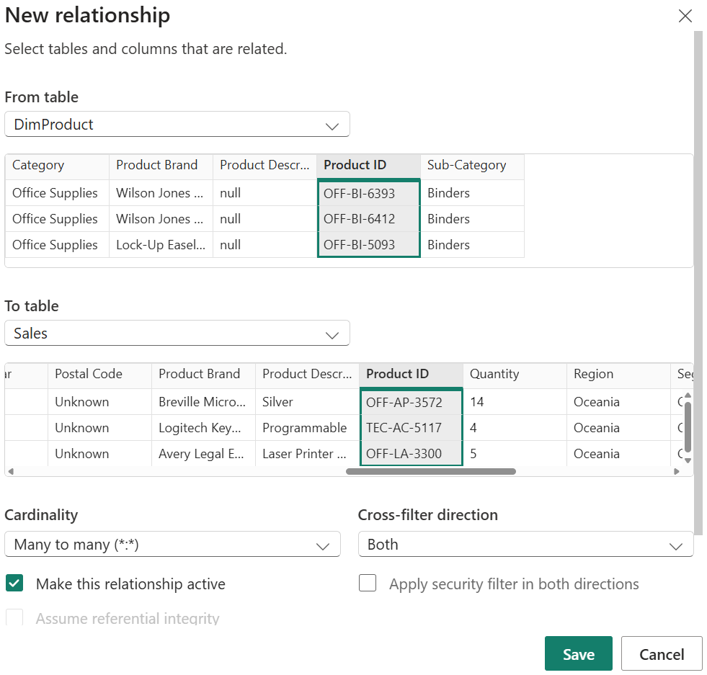

DimGeography to Sales
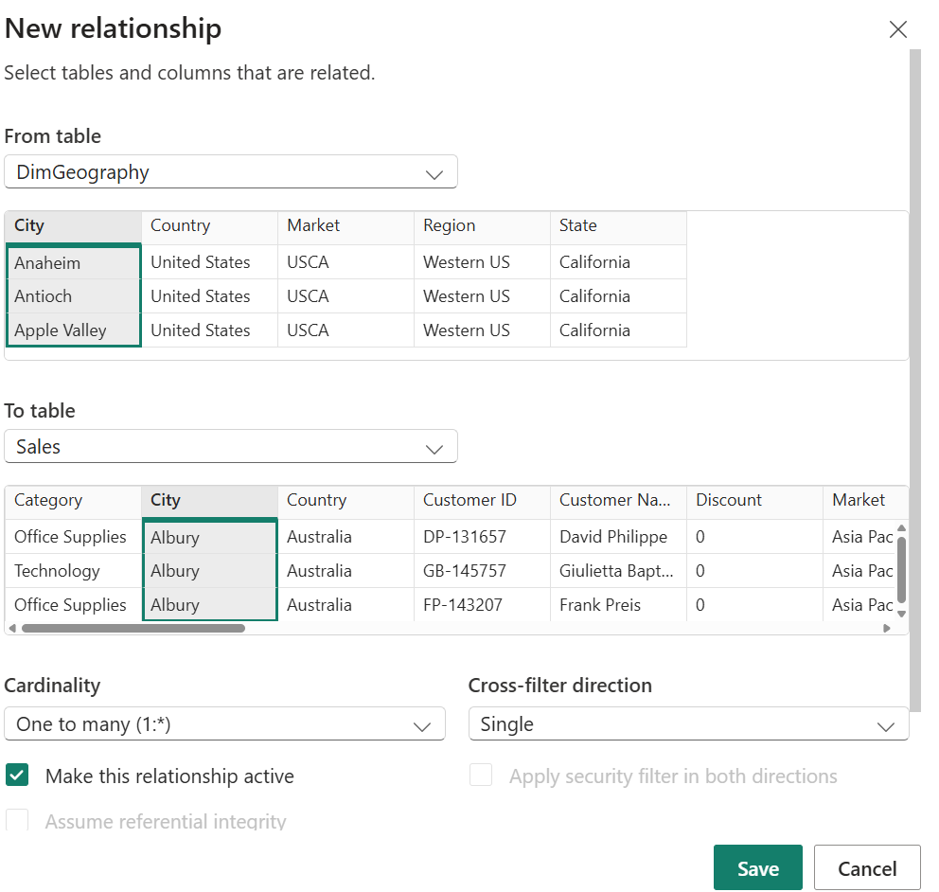

DimCustomer to Sales
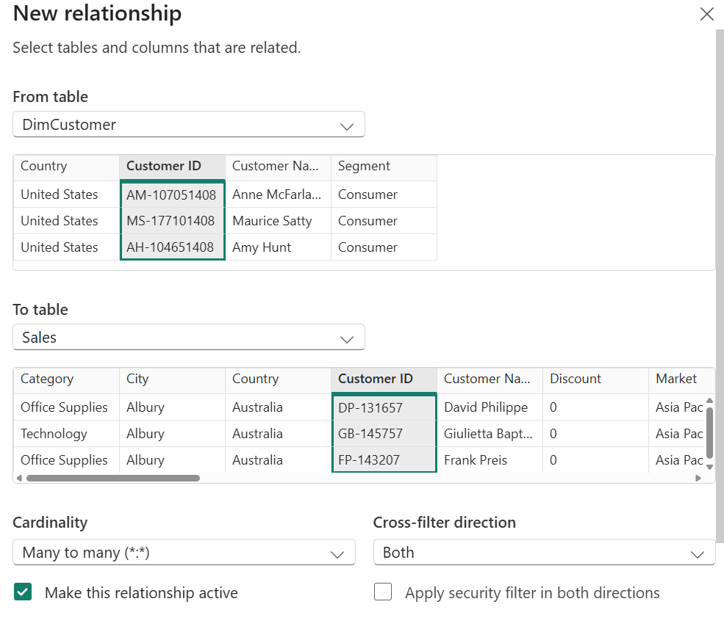

STAR SCHEMA:
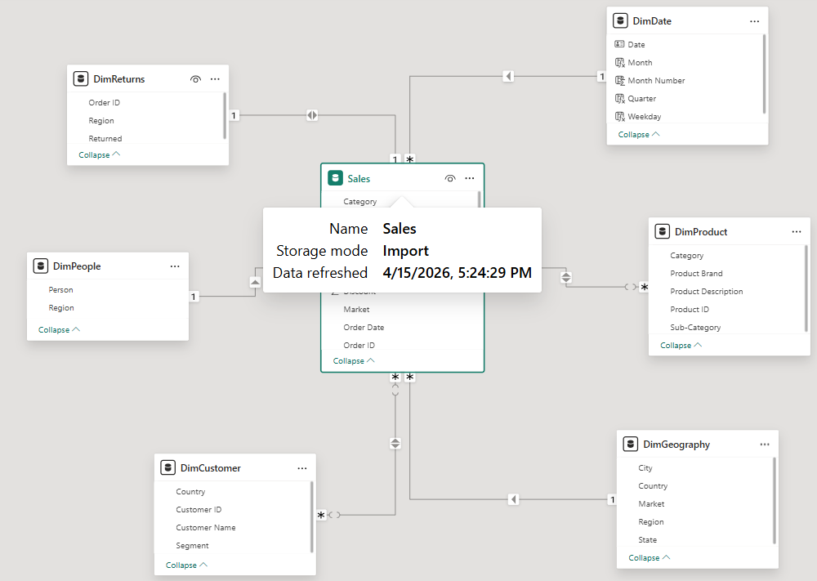

Part D: DAX Measures
Measure 1: Total Sales


Measure 2: Total Profit
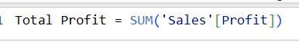

Measure 3: Total Quality
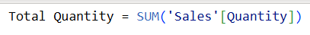

Measure 4: Profit Margins percentage

Measure 5: Distinct Customers

Measure 6: Total Orders

Measure 7:Average Order Value
Measure 8: Sales year to Date

Measure 9: Previous Year Sales

Measure 10: Sales Growth %

Measure 11: Return Rate

Measure 12: Top Category Rank

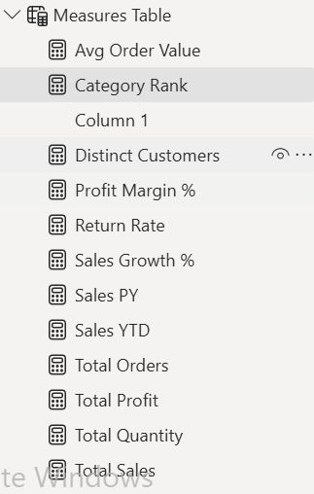

Calculated Columns
I added new calculated columns in the sales table

Calculated Column 1: Profit per unit

Calculated Column 2: Sales Tier
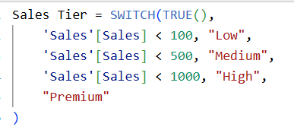

Part E: Dashboard
Dashboard link:
https://app.powerbi.com/view?r=eyJrIjoiMmM0NTQ5MWYtNWQ1OC00ZjY5LWEzMTYtZDEzNjViNGQwNWE0IiwidCI6IjE2ZDgzZWU2LTI1NGEtNDY5ZC1hNmNjLTU0ZTJjYTIzMTNlNyIsImMiOjh9

Executive Summary Page
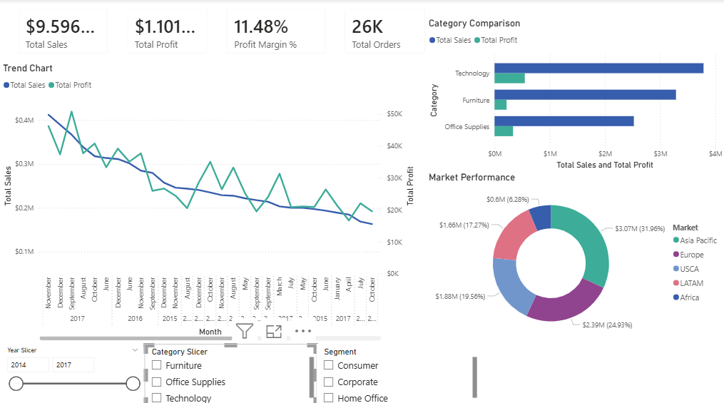

Detailed Analysis Page:
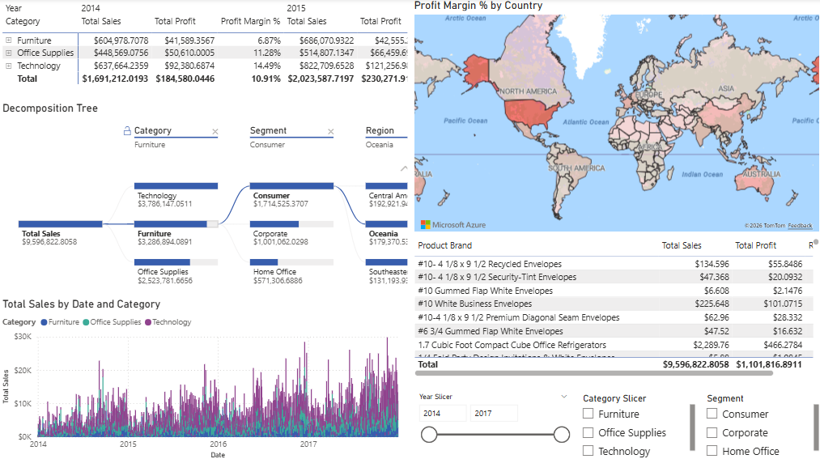

Insights and Performance Page
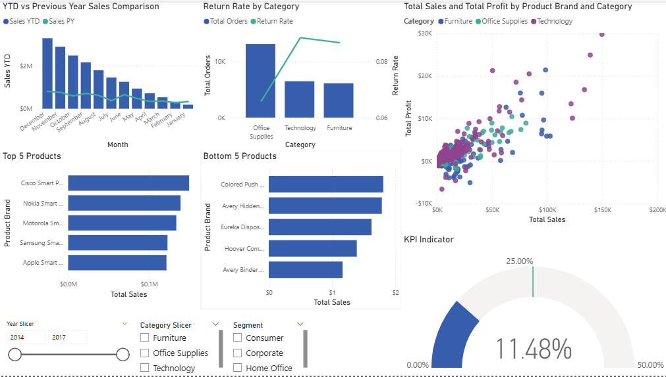

Part F: Analytical Insights

Insight 1: technology Category Drives both Sales and Profitability
- The Technology Category outperforms both furniture and office supplies in the absolute profit margin. With a 14.49% margin versus Furniture's 6.87%, technology generates more than double the return on sales. This suggests the company should consider expanding technology offerings while evaluating why furniture under performs.

Insight 2: Furniture Category is a Profitability Concern
- Furniture generates the second-highest sales volume but the lowest profit margin. The category may be suffering from high shipping costs, excessive discounting, or unprofitable sub-categories like Tables and Bookcases.

Insight 3: Consumer Segment Dominates Sales Volume
- The consumer segment represents the largest customer base, appearing consistently across all categories in the decomposition tree. However, Corporate and Home Office Segments show comparable profit margins. The company should evaluate whether marketing spending is appropriately allocated. Consumer drives volume, but corporate may offer better customer lifetime value.

Insight 4: APAC and Europe Markets Lead Performance
- The Us/Canada market represent nearly 25% of total sales, making it the company’s largest revenue source. Europe and Asia Pacific together contribute another 37%. Africa and Latin America, while smaller, may represent growth opportunities. However, profitability by market should be examined as high sales volume does not always equal high profit.

Insight 5: Time Series Shows Cyclical trends
- The time series plot shows that every year there is a spike towards the middle of the year and the end of the year signaling purchases increase during the summer holidays and the December holidays.

Recommendation:

Recommendation 1: Restructure the Furniture Category for Profitability
- Improve the current margin by identifying the bottom 5 under-performing products, strictly limiting discounts by identifying the bottom 5 under-performing products, strictly limiting discounts on bulky items like tables and bookcases, and negotiating better shipping rates to reduce overhead costs.

Recommendation 2: Scale High-Margin technology growth
- Capitalize on Technology's superior margin by increasing inventory for top products ahead of Q4 spikes,testing higher price points for accessories, and cross-selling tech items with standard office supplies to increase average transaction value.

Recommendation 3: Implement Dynamic discounting by region
- To improve overall profitability, the company should implement dynamic discounting by reducing the maximum allowable discounts in under performing regions like Africa and Central Asia, while simultaneously testing the removal of discounts on high demand technology in profitable regions like APAC. To further increase average order values in these strong markets, a 200$ free shipping threshold should be introduced, allowing the remaining promotional budget to be reallocated towards targeted efforts for clearing slow inventory.

Conclusion
This Power BI solution successfully transforms raw operational data into an interactive decision-support system. The star schema model supports efficient querying, while 12 DAX measures enable sophisticated time intelligence and performance analysis. The three-page dashboard provides stakeholders with executive summaries, detailed Analytics, and actionable insights. Key findings reveal a 9.2% return rate in Technology category and significant market profit imbalances, leading to three specific operational recommendations.

